For emails of WooCommerce orders make sure you have enabled mailing feature:

1) Go to dashboard. Select woocommerce settings. Go to emails.

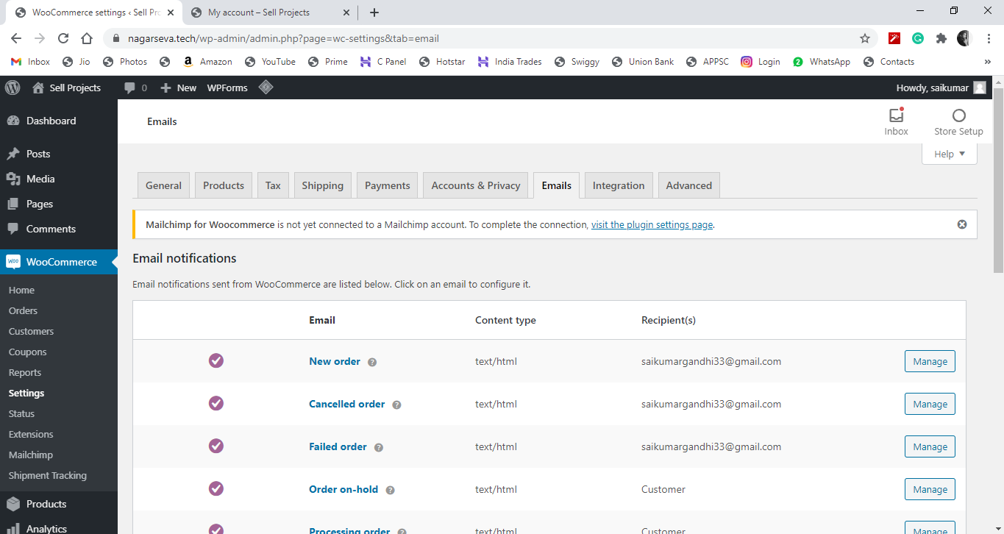

2) See that new order, cancelled order and failed order are set to recipient as admin mail.

If not , click on manage, set recipients mail, and also enable the checkbox.

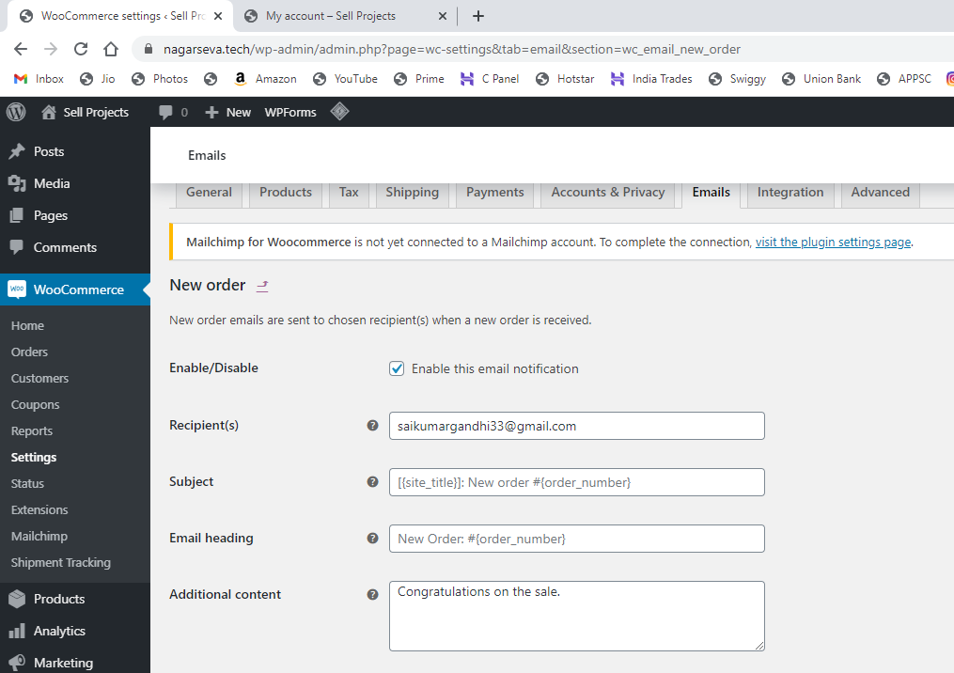

3) For other email make sure recipient is set to **customer**  and they all are enabled. If not enable them to send mails to customer automatically.

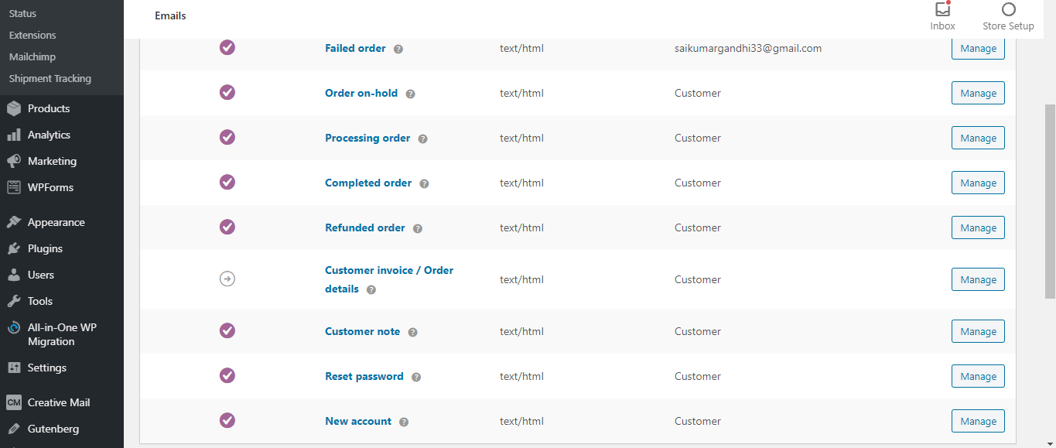

4) For customers to receive emails they need to check the get newsletter and email content.

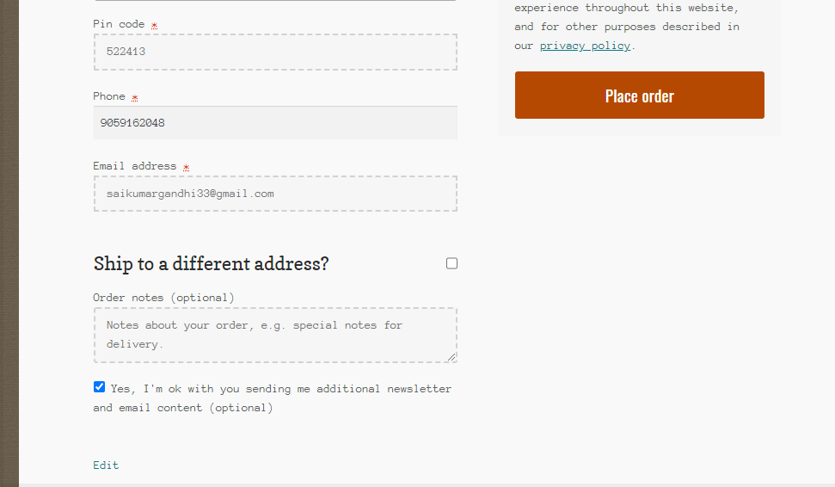

5) After placing order both owner and customer gets emails.

Owner gets : New order mail as follows

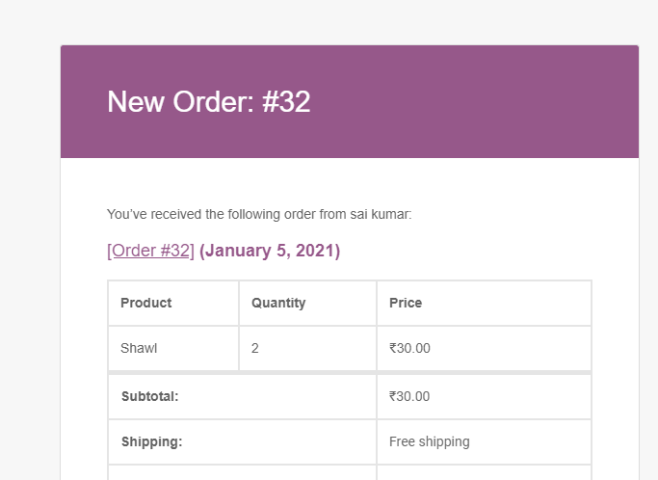

Customer gets : Your order been received ….

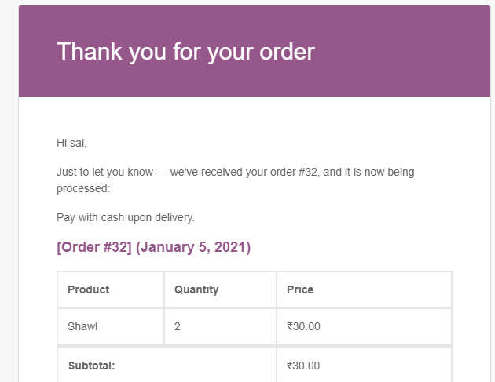

6) In the Woocommerce shipment tracking page , go to settings and check the Completed and Onhold in Email display

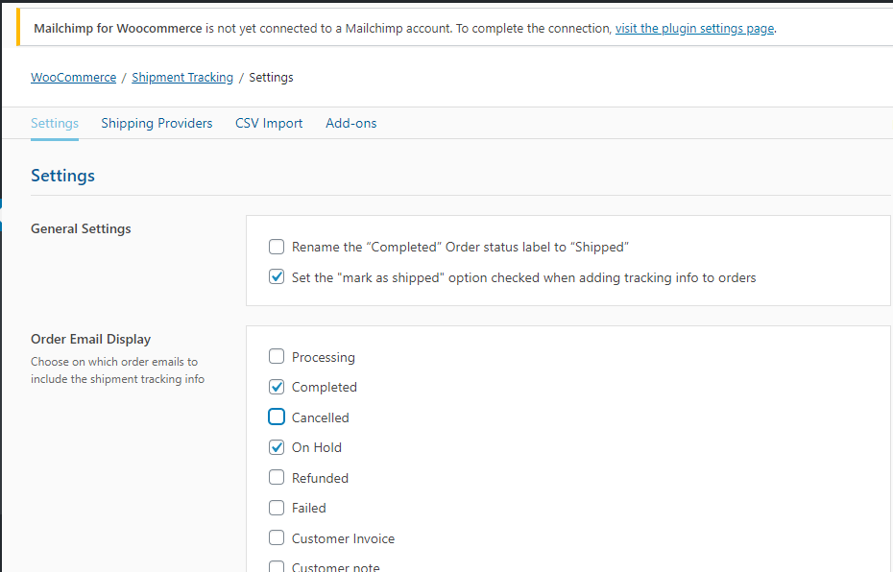

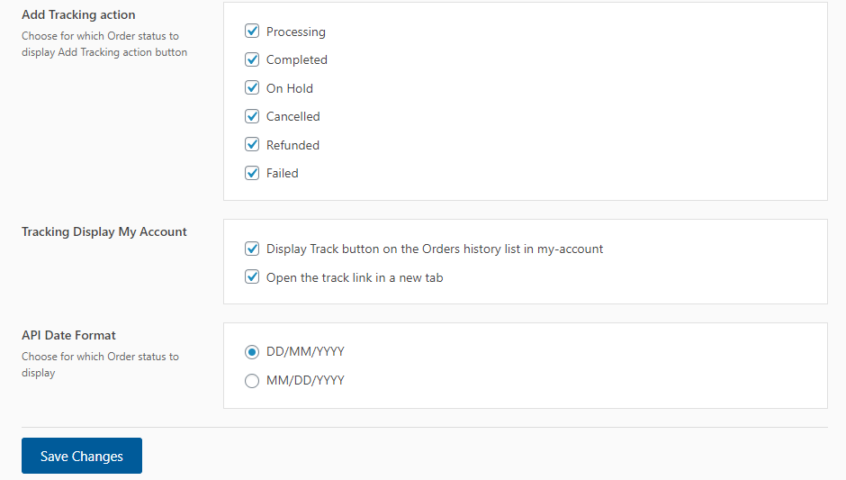

7) Now open shipping providers and select custom providers and add customer provider

